Certification Process
Reliable Certification (SMC-Private) Limited
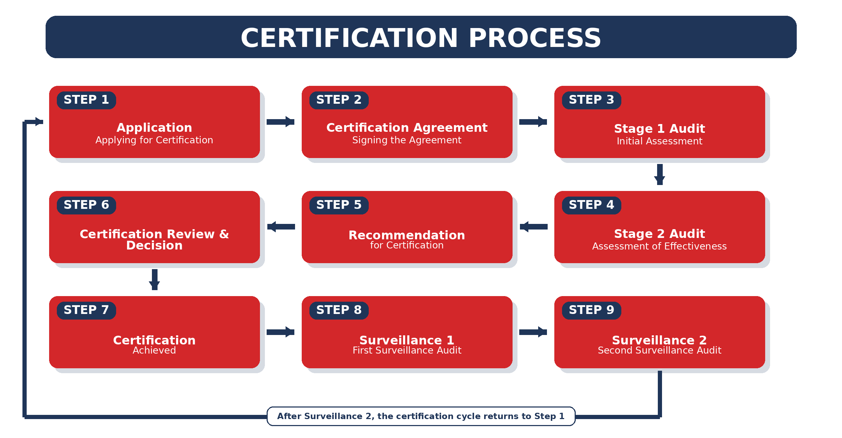
This process illustrates the certification sequence from initial application through certification, Surveillance 1 and Surveillance 2, after which the cycle returns to Step 1.

